Week 5

**Question:** Which of the following is a measure of the amount of variance explained by a principal component in Principal Component Analysis (PCA)?

1. Covariance
2. Correlation
3. Mean absolute deviation
4. Eigenvalue

**Correct Answer:** 4. **Eigenvalue**

In Principal Component Analysis (PCA), the eigenvalue of a principal component is a measure of the amount of variance explained by that component. Each eigenvalue corresponds to a principal component and indicates how much of the data's total variance is captured by that component.

What is/are the limitations of PCA?

 It can only identify linear relationships in the data.

 It can be sensitive to outliers in the data.

Q. Which of the following is a property of eigenvalues of a symmetric matrix?

1. All eigenvalues of a symmetric matrix are real numbers.
2. Eigenvectors corresponding to distinct eigenvalues are orthogonal.
3. A symmetric matrix can be diagonalized by an orthogonal matrix.
4. The algebraic multiplicity equals the geometric multiplicity for eigenvalues.
5. Eigenvalues of a positive definite symmetric matrix are all positive.



If we have a 12×12 matrix having entries from R, how many linearly independent eigenvectors corresponding to real eigenvalues are possible for this matrix?



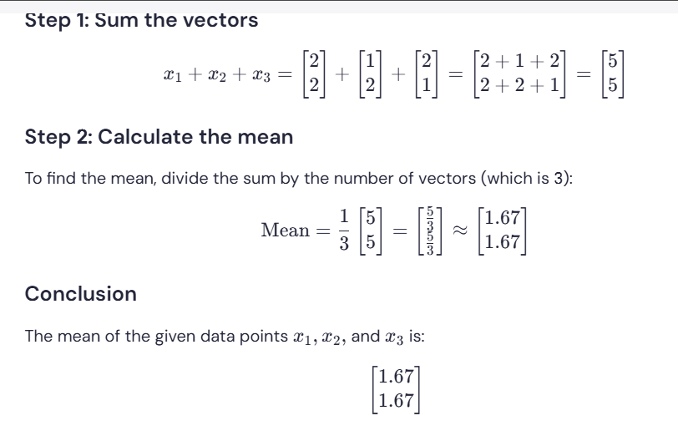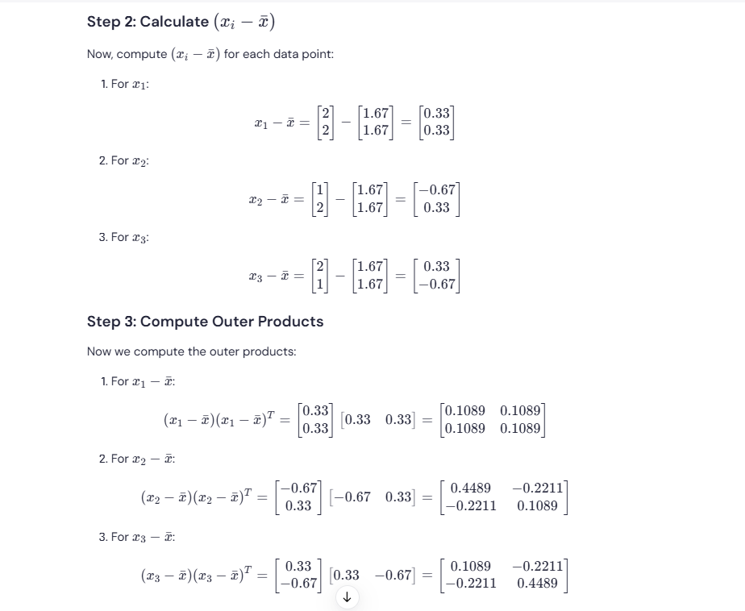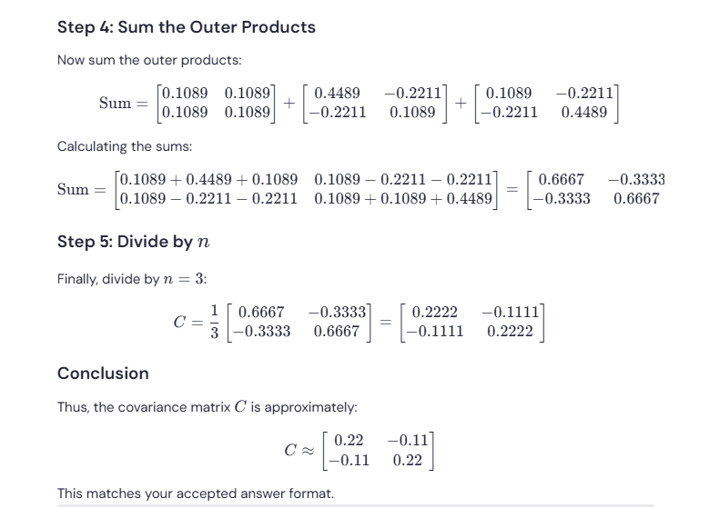

The maximum eigenvalue of the covariance matrix C is:

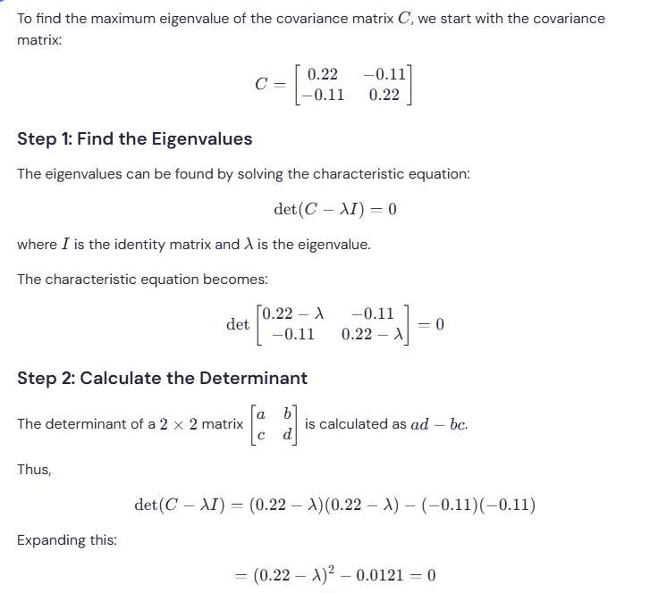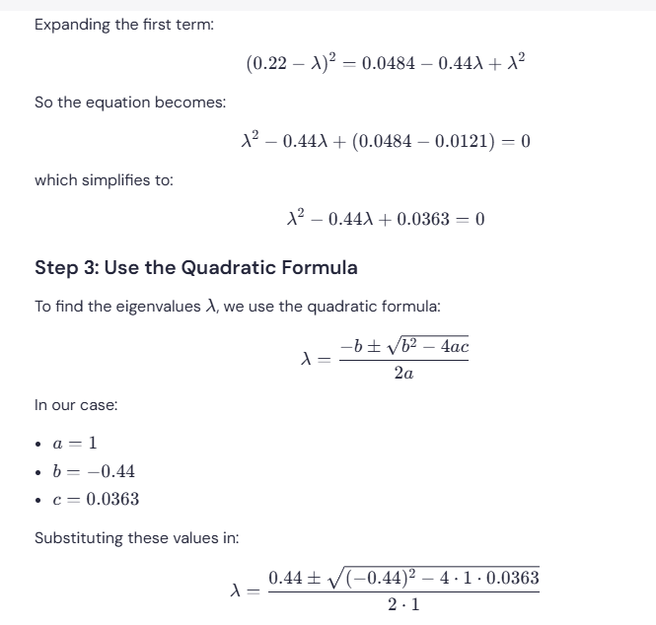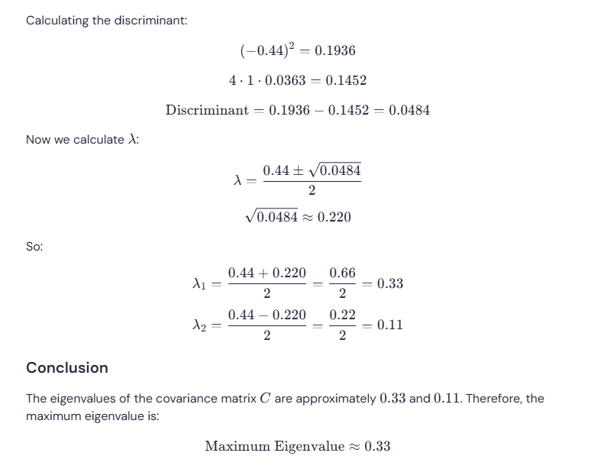

The eigenvector corresponding to the maximum eigenvalue of the given matrix C is:

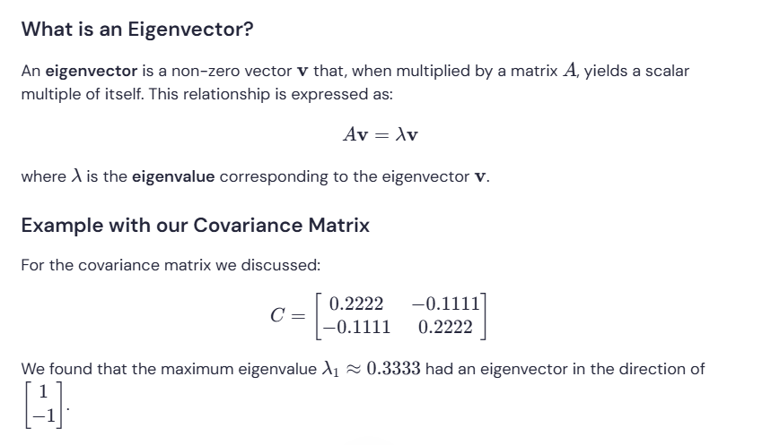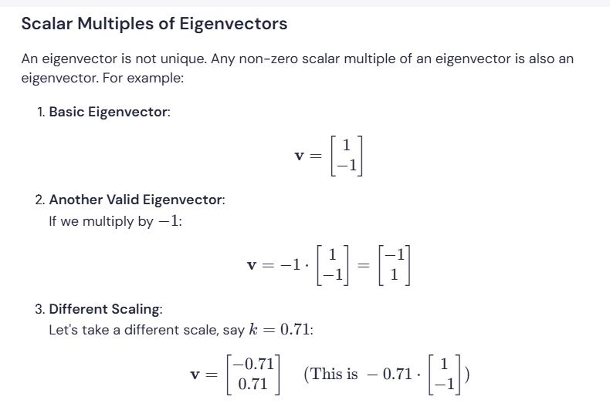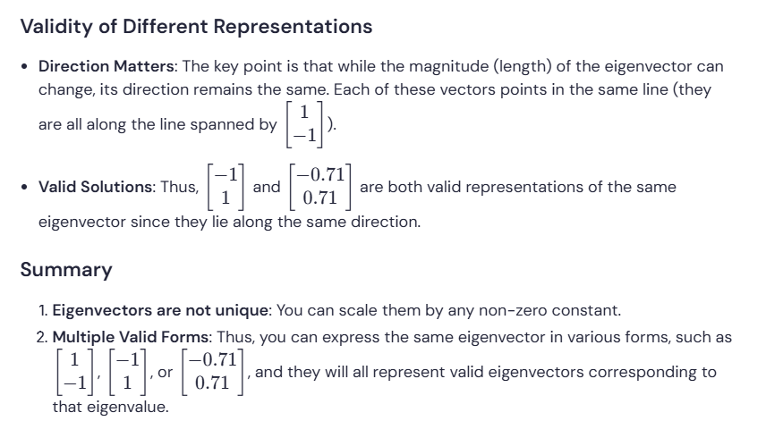

What is the determinant of a 2×2 matrix that has eigenvalues of 4 and 5?

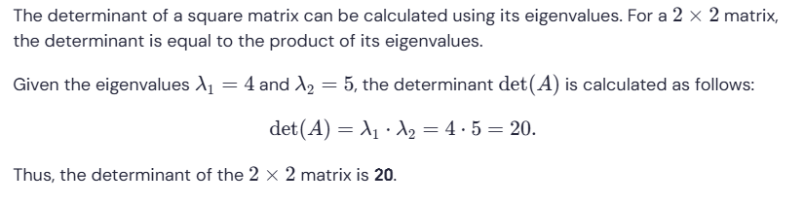

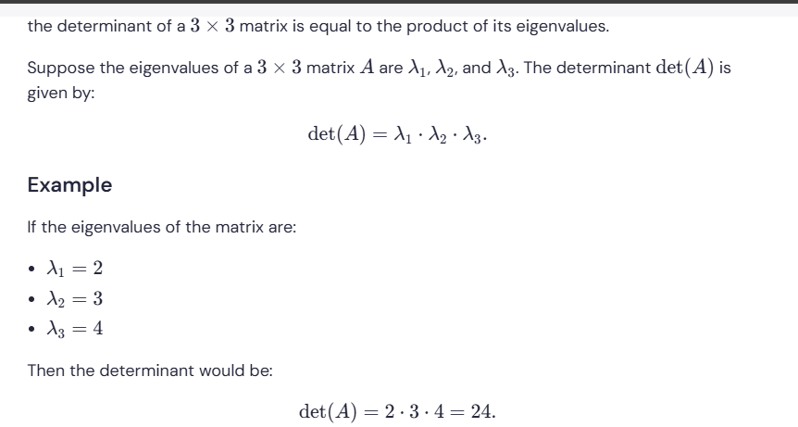





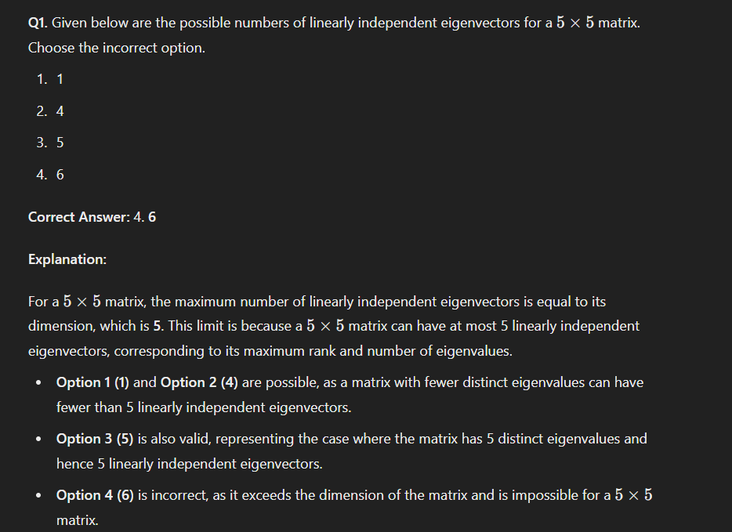  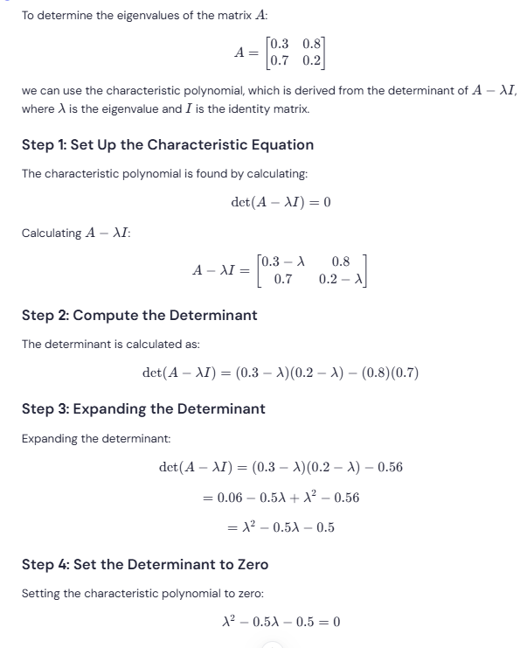 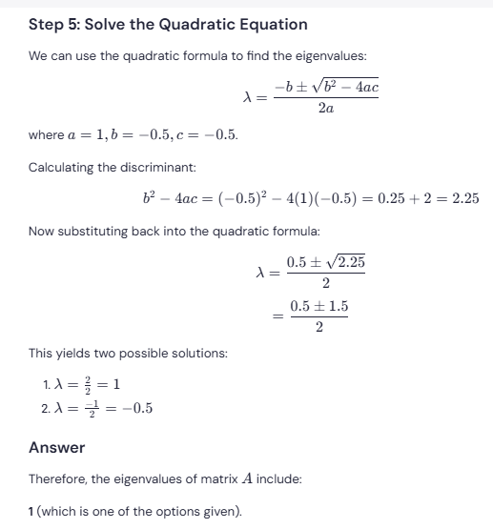 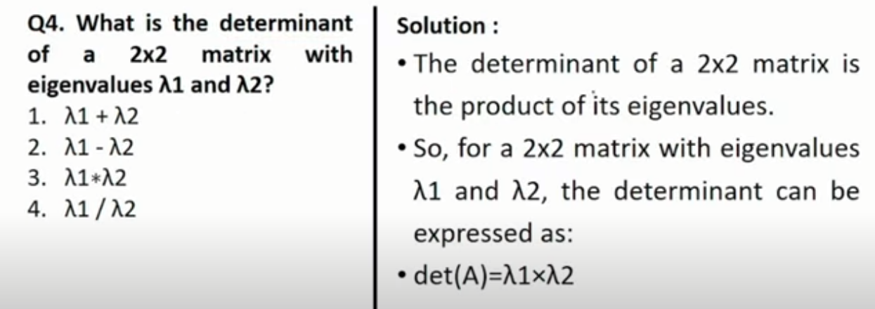

Here's the text from the image:

**Q4. What is the determinant of a 2x2 matrix with eigenvalues λ1 and λ2?**

1. λ1 + λ2
2. λ1 - λ2
3. λ1 * λ2
4. λ1 / λ2

**Solution:**

* The determinant of a 2x2 matrix is the product of its eigenvalues.
* So, for a 2x2 matrix with eigenvalues λ1 and λ2, the determinant can be expressed as:
* det(A) = λ1 * λ2

Therefore, the correct answer is option 3.

